**React App for E-Commerce Website**

Contents

Document Description 2

Change Log 2

User Stories 3

Style Guide 9

Code guidelines 14

HTML 14

CSS 14

Fonts 14

Colour Palette 14

# Document Description

This document describes the business requirements that need to be implemented for completing a portfolio page for describing oneself.

# Change Log

|  |  |  |  |  |
| --- | --- | --- | --- | --- |
| S. No. | Update | Version | Updated By | Updated On |
| 1. | Created the document for functional specifications for the application | 1.0 | Vaibhav Vashishtha | 12th Sept’20 |
| 2 | Updated the document as per the react application created | 1.1 | Kannan Azhagappa | 16th Nov’20 |

# User Stories

|  |  |  |  |
| --- | --- | --- | --- |
| User Story ID | As a (user) | I want to (task) | So that I can (result) |
| 1 | As a person who visits the E-Commerce Website | Should be able to see details about the App in Home Page | So that I can know more about the App |
| 2 | As a person who visits the E-Commerce Website | Should be able to see the Sign in Page | So that the User can login |
| 3 | As a person who visits the E-Commerce Website | Should be able to see the Sign Up Page | So that the User can sign up for the App |
| 4 | As a person who visits the E-Commerce Website | Should be able to see error validation messages for both Sign Up and Sign In Pages | So that the user is aware of the errors |
| 5 | As a person who visits the E-Commerce Website | Should be able to see their profile once successfully login | So that the user is aware of their profile |
| 6 | As a person who visits the E-Commerce Website | Should be able to see the Product Catalogue | So that the user is aware of the products |
| 7 | As a person who visits the E-Commerce Website | Should be able to product details in high level | So that the user understands about the product |
| 8 | As a person who visits the E-Commerce Website | Should be able to option to add to cart | So that the user can choose items to add to cart |
| 9 | As a person who visits the E-Commerce Website | Should be able to see their cart | So that the user knows what they have added to their cart |
| 10 | As a person who visits the E-Commerce Website | Should be able to see their price total for the products selected | So that the user sees the amount they need to pay |
| 11 | As a person who visits the E-Commerce Website | Should be able to remove cart items | So that the user can unselect the products not needed any more |
| 12 | As a person who visits the E-Commerce Website | Should be able to sign out from the App | So that the user can safely come out from the App |
| 13 | As a person who visits the E-Commerce Website | Should be able to see product and cart page only after login in | So that the user is authenticated before enjoying the app functions |

Layout of the App

This section defines the standards for the look and feel of the page

Home Page:

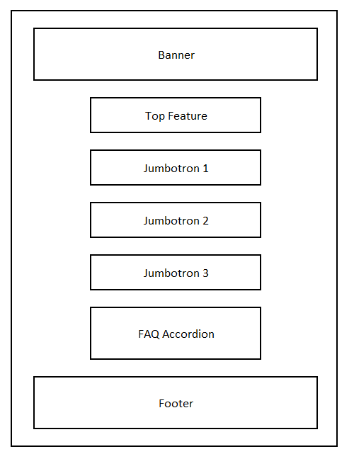

Sign Up & Sign In Pages:

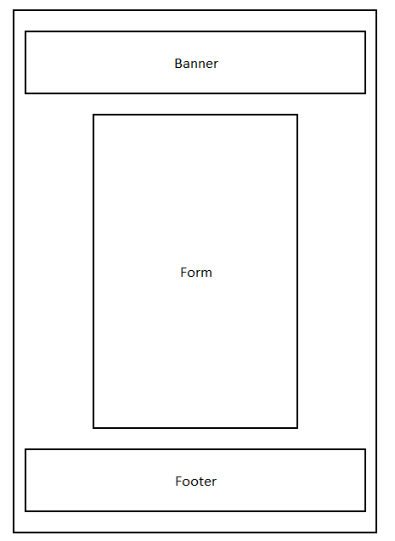

Profile Page:

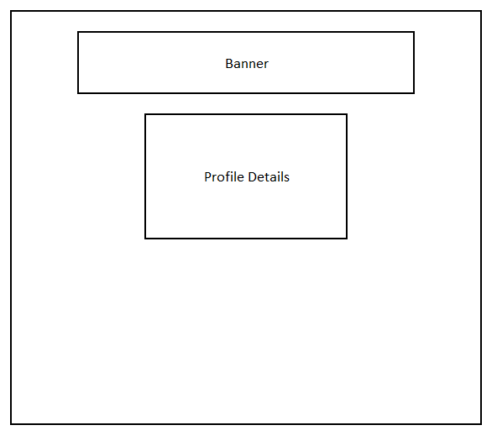

Browse Page:

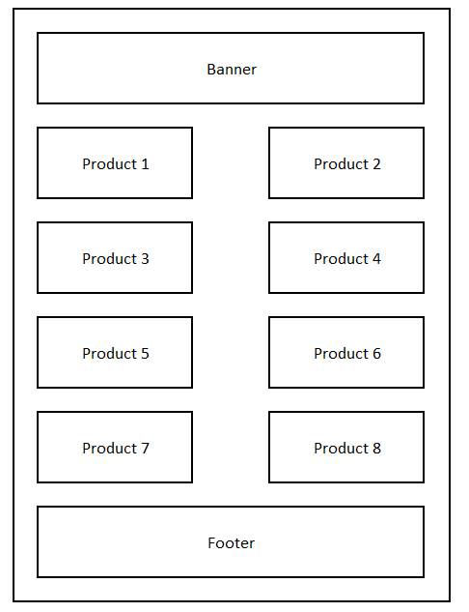

Check Out Page:

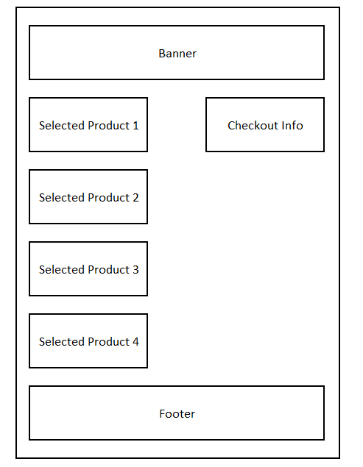

All this design are responsive to size of the screen and it will stack up accordingly.

# Style Guide

This guide defines the standards that will be followed while developing and styling the web page using CSS.

* Generic style for the complete page (For font family mainly)
* Generic background style for the body of the page
* Generic style for any list and anchor links in the page
* Generic style for the name and its container
* Generic style for the description
* Generic style for the image
* Generic style for the banner
* Styled components
* Some Components with Raw CSS Stylings
* Generic style for Buttons
* Material UI and Image Icons for Banners, Loading, User Profiles and Search Options
* Media Queries to make the website responsive

Outlook of the Application:





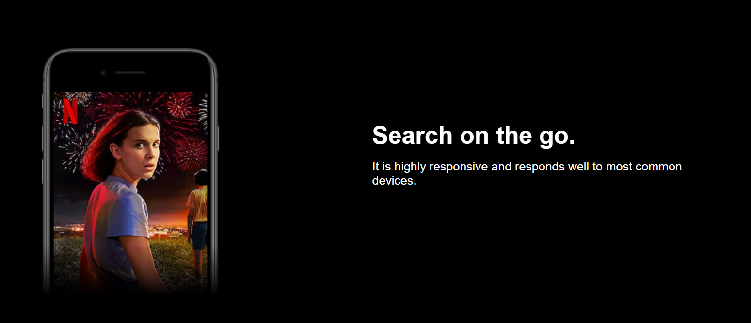

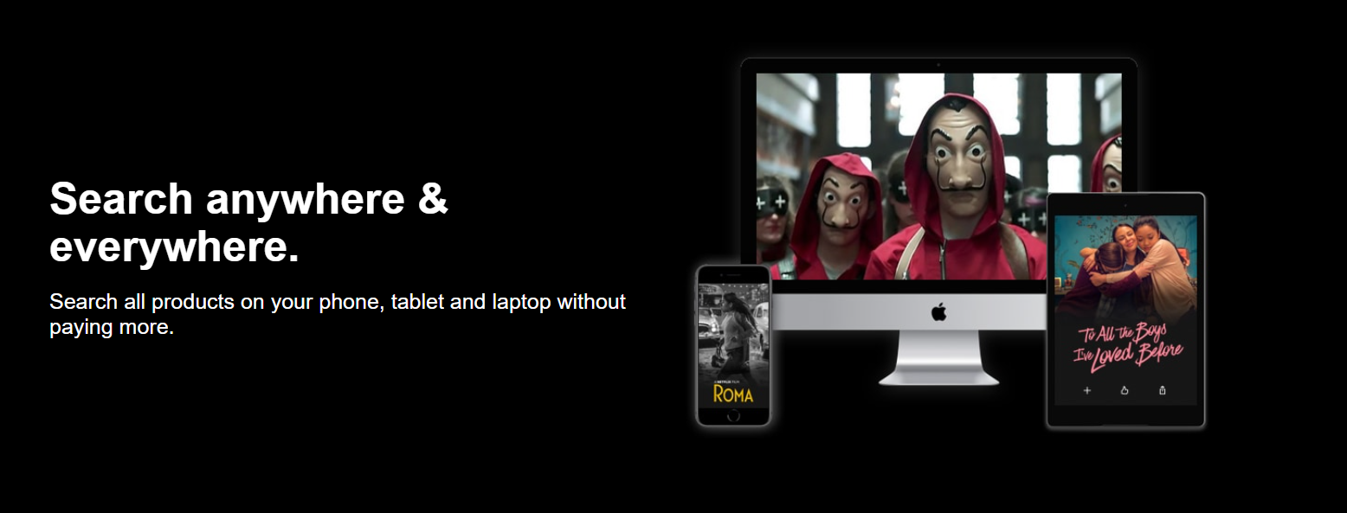

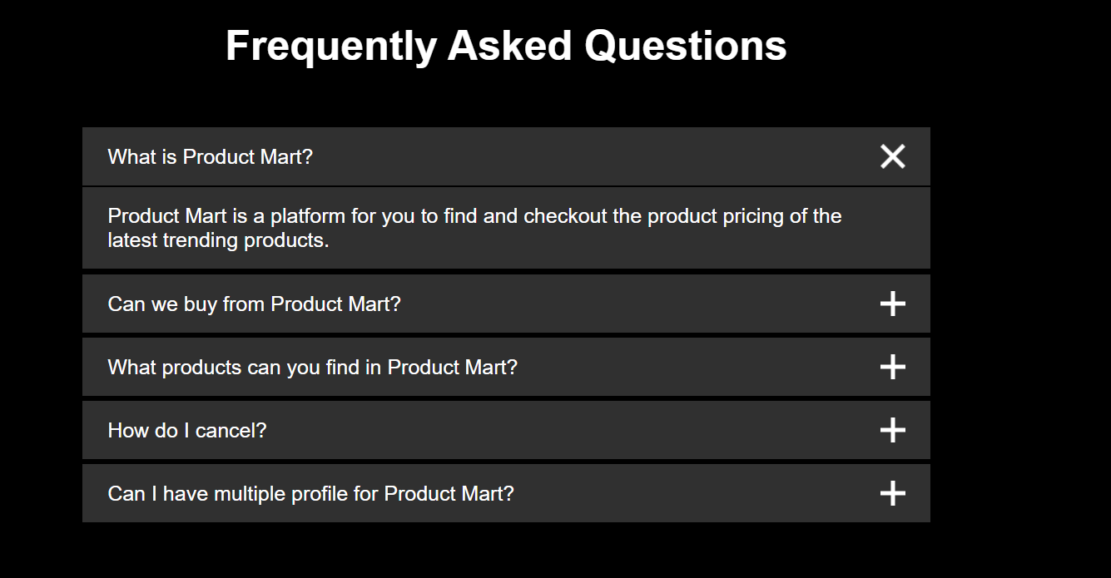

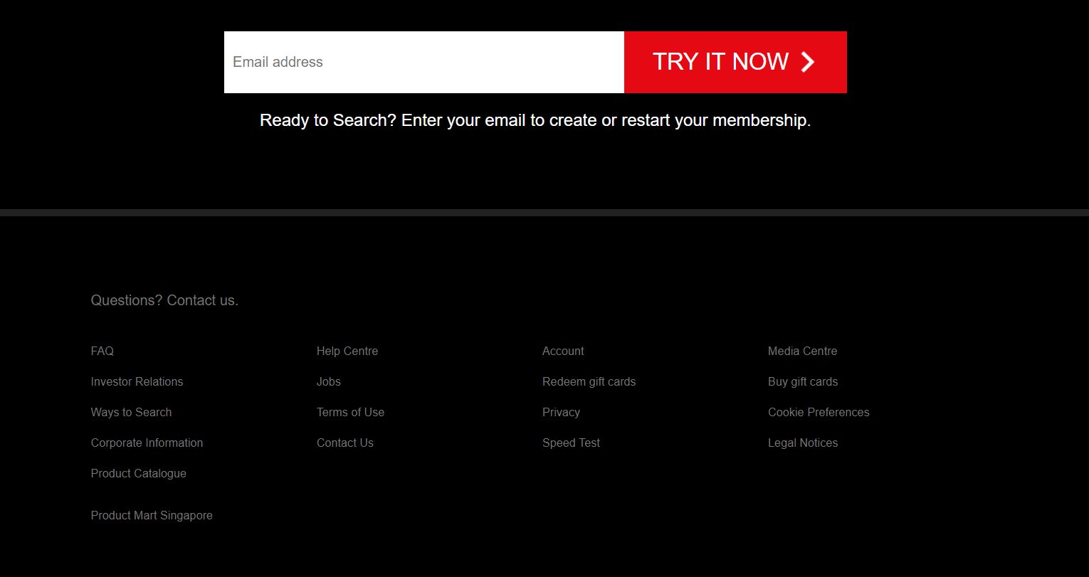







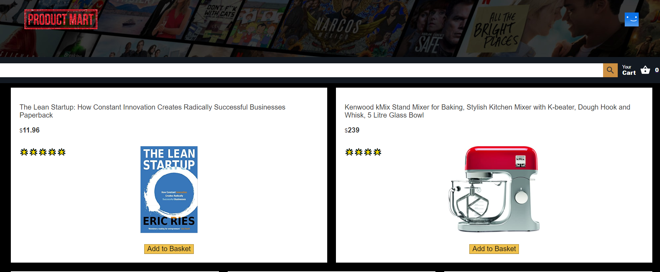

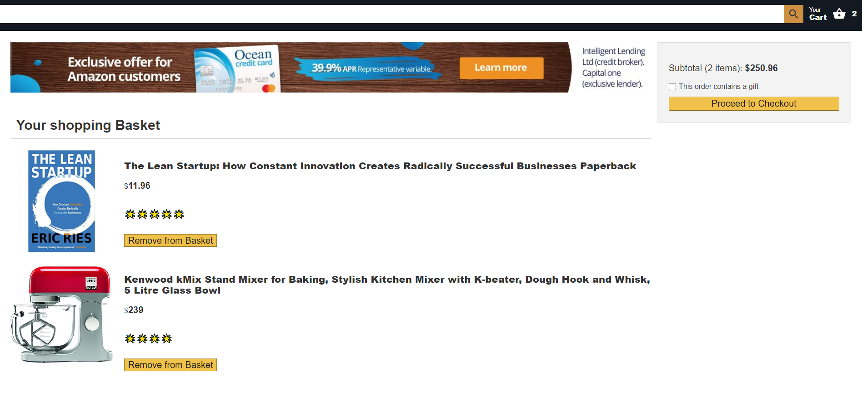

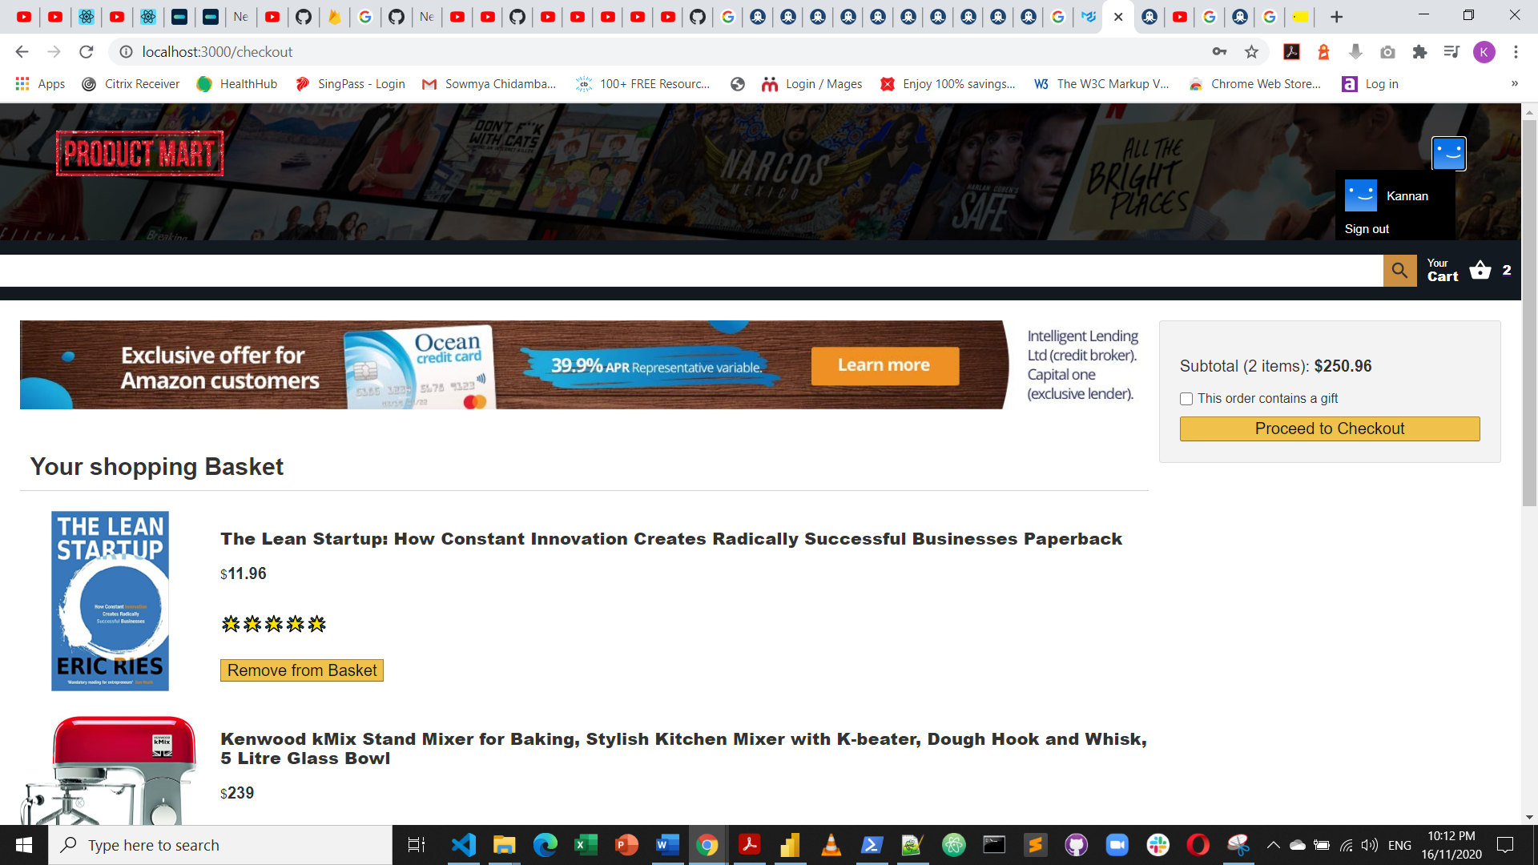

# Code guidelines

This section defines the coding standards that will be followed during the development of the web page

### HTML

* Always Doctype Header
* Use a new line for all elements
* Wrap long lines
* For attribute values use double quotes and no single quotes

### CSS

* Use meaningful selector names
* Try and reuse classes
* Try and avoid type selectors for qualification
* Do not use units for 0 values
* Avoid hacks

# Fonts

Mainly four variation of fonts for this entire App but with variation in the sizes as per the elements. The fonts used are Helvetica Neue, Helvetica, Arial and sans-serif.

# Colour Palette

* Main colours
  + Red
  + White
  + Black
  + Yellow
  + Grey
  + Orange